A user interface (UI) is what allows a user to interact with a program and a UI designer is responsible for making those interactions as clear and enjoyable as possible. In this lab, you’ll learn a bit more about what UI design is and the tools available in Unity to help you create UIs. Then, you’ll open your project and begin customizing your scene.
By the end of this lab, you'll be able to:
- Define "UI" and the role of user interfaces in real-time 3D experiences.
- Differentiate between UI design and other related disciplines, like User Experience Design and Information Architecture.
- Distinguish between Unity's three available UI systems: uGUI (or Unity UI), IMGUI (or “Immediate Mode” GUI), and UI Toolkit.

- Overview

A User interface (UI) is any system that allows a user to interact ( interface) with a computer or computer application.
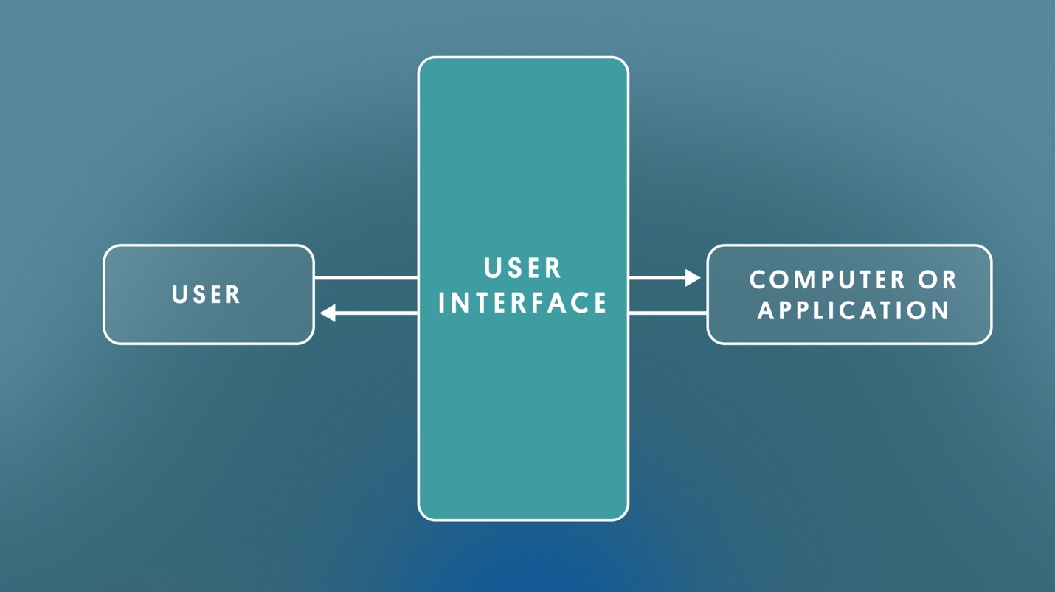
In the context of real-time 3D projects, a UI is usually a combination of text, buttons, checkboxes, sliders, and toggles.
These elements can communicate with the user using rules or notifications. UI can also help the user carry out tasks, such as saving progress or adjusting settings.

What does a UI designer do?

Responsibilities
UI designers mostly concern themselves with what the UI elements look like and where they’re located on screen. More specifically, a UI designer will:
- Design menus, buttons, HUDs, pop-ups, etc. according to the art direction.
- Make sure all relevant information and functionality is present through the various UIs.
- Design with technical constraints and optimization guidelines in mind.
If the UI designer is comfortable with basic programming, they may also be asked to implement some simple UI functionality. More complex UI functionality, such as a character customization screen, would fall to a programmer.

Background
Most UI artists have the following foundational skills and experience:
- Traditional artistic skills, including knowledge of proportion, composition, color, etc.
- Good understanding of usability, clarity, and accessibility of interfaces.
- Up-to-date with the current design and typographical trends.
Basic programming is a plus, since UI is usually tied to simple functionality.

Tools
In addition to Unity, UI designers might use or be familiar with other software programs, including:
- 2D image editing software, such as Adobe Photoshop, to create textures and lay out interfaces.
- 2D vector illustration tools, such as Adobe Illustrator, to draw images, buttons, and icons.

What is UI design?
UI design is the process of laying out graphical UI (GUI) elements in a compelling, yet intuitive way. UI should be clear, consistent, accessible, and appealing. When you’re using a well-designed UI, the experience is seamless and enjoyable.
If you’re not thinking about the UI design very much as you’re using it, that’s usually a good sign.

What UI design is not
However, defining UI design can get confusing when you consider it alongside similar-sounding areas like user experience and user interaction design.
Below are some of those disciplines and how they relate to each other:
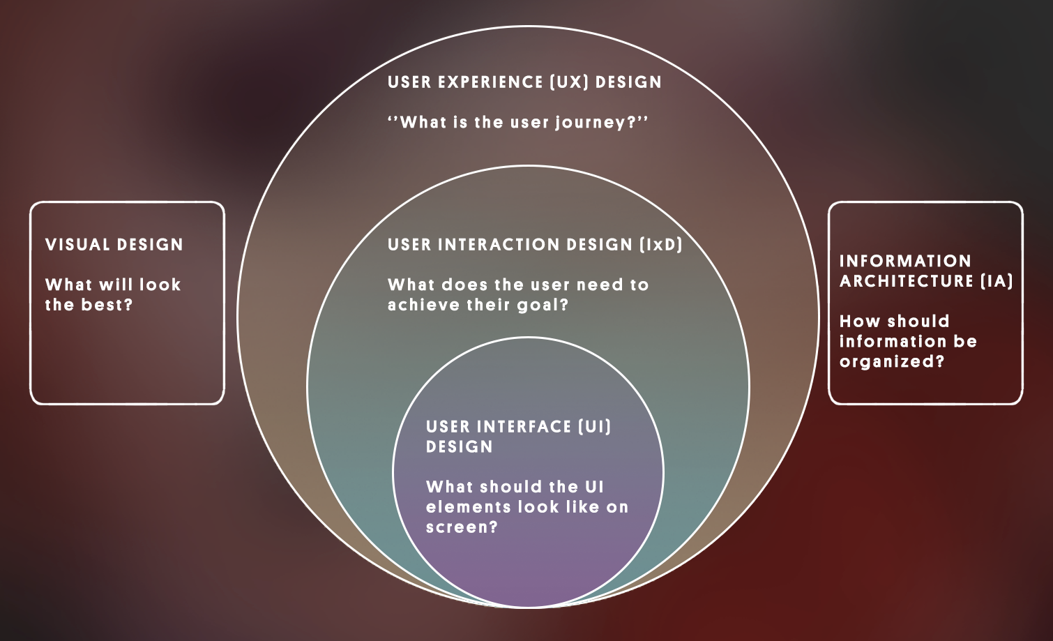
User experience (UX) design
- Answers the question: What’s the user journey?
- Goal: Ensure a positive overall experience with a product from start to finish.
User interaction design (IxD)
- Answers the question: What does the user need to achieve their goal?
- Goal: Allow users to accomplish their goals in the most efficient way.
- Is part of UX design.
User interface (UI) design
- Answers the question: What should the UI elements look like on screen?
- Goal: Make the interface easy to understand and easy to use without getting in the way.
- Is part of IxD, which is part of UX.
Information architecture
- Answers the question: How should information be organized and structured (not necessarily for interactions)?
- Goal: Structure content so users know where to go to find the information they need.
- Informs UI design, IxD and UX design.
Visual design
- Answers the question: What will look the best (not necessarily for interactions)?
- Goal: Make something visually appealing.
- Informs UI design, IxD and UX design.
There is no clear consensus on the precise differences between these disciplines, but it’s helpful to be aware of how these terms relate to each other at a high level.
What might have been the responsibility of someone working in each of the following disciplines in order to arrive at the final product shown above?
- User experience design
- Interaction design
- User interface design
- Information architecture
- Visual design
- User experience: Ensure the experience of equipping items is fun and satisfying for the user.
- Interaction design: Ensure the user can equip or use items in two clicks or fewer.
- User interface: Design the icons and interface layout so that it is very clear what everything is.
- Information architecture: Determine if it makes sense to split up items that can be equipped vs items that cannot.
- Visual design: Select the best possible colors for the background and text.
Now that you know what a UI designer does, let’s open Unity so you can try it for yourself!

Open the project from the Unity Hub.
In the Unity Editor’s Project window, open Assets > CreativeCore_UI > Scenes and then open the scene TutorialScene_UI_Outdoor.
In the TutorialScene_UI_Outdoor scene, you will find an outdoor scene with a single street lamp in it.
Press Play. What you see in Game view will be the backdrop of your UI. The title and menus will sit on top of what you see there.
If you don’t really care what your final project looks like, you can skip this step and just use what is currently framed in the Game view.
However, if you want to personalize your UI scene, take some time now to make it look how you want. With just a few quick changes to the scene and your camera position, it could look very different.
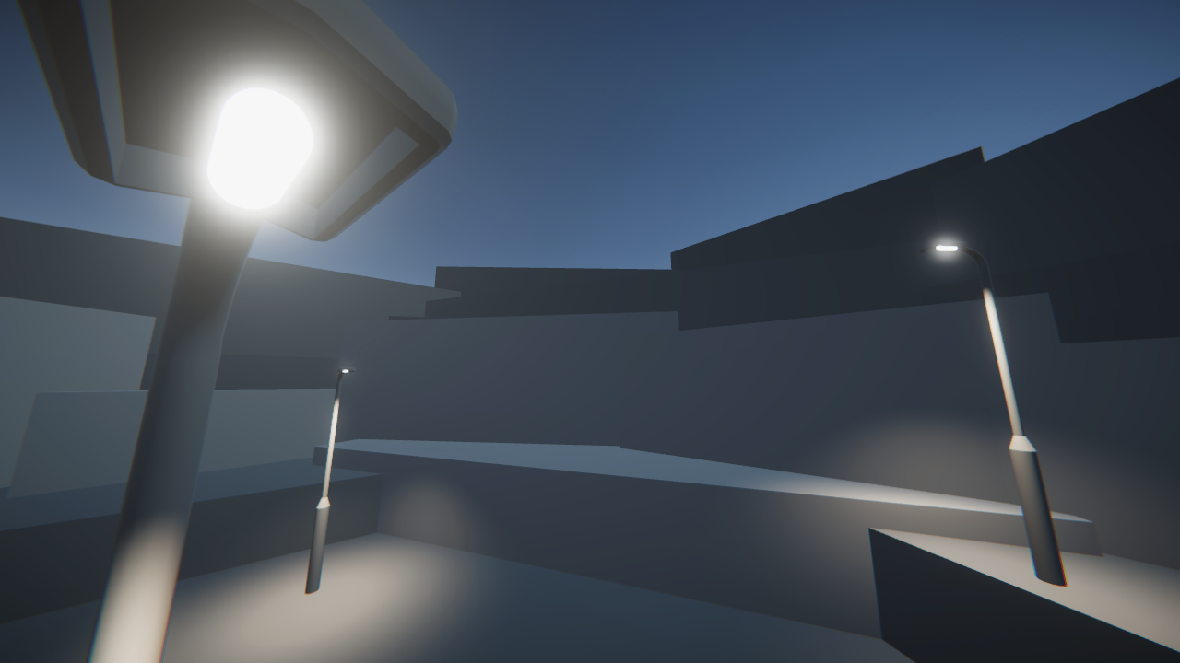
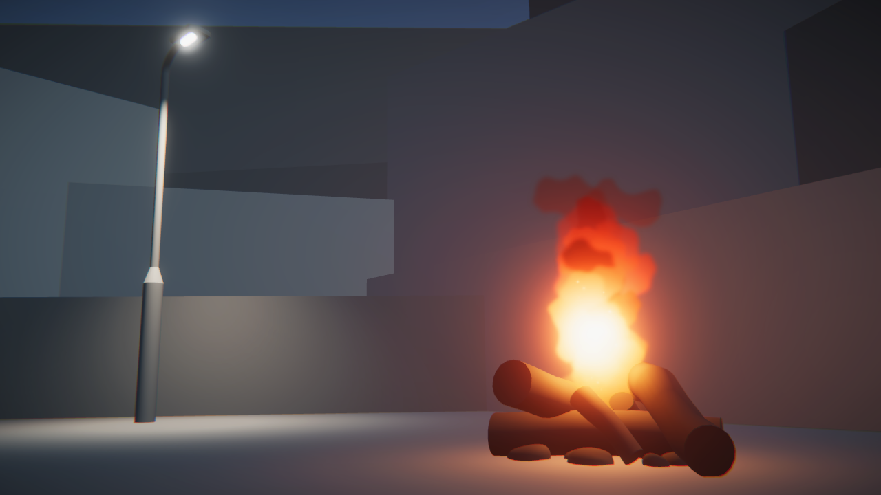
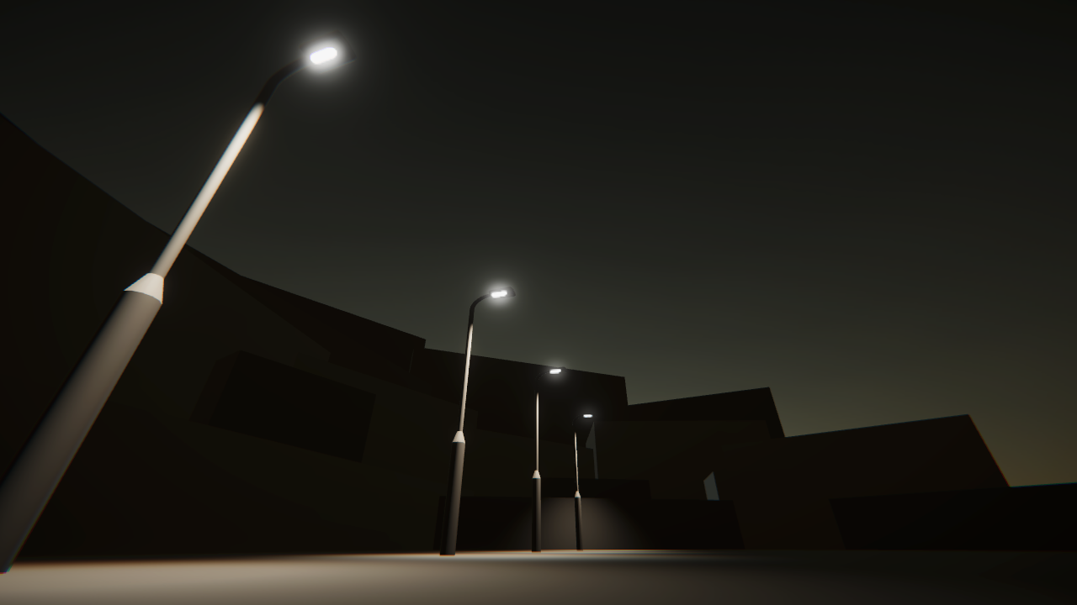
1. From the Project window, in Assets > CreativeCore_UI > Prefabss, add additional props to your scene that you want to include in your UI backdrop. You can also use primitive shapes like cubes and spheres to build your own custom objects. If you’re familiar with Probuilder, you can use that too!
2. Adjust the Rotation, Color, and Intensity of the Directional Light to change the time of day.
3. Reposition the Main Camera to frame the objects nicely in your scene. Use the Field of View property to expand or restrict what’s in frame.
Once you have your scene framed just right, you’re ready to move on!

Which Unity UI system to use?

Before you start adding new UI elements, you should know that there are actually three entirely separate systems available for developing UIs in Unity: uGUI, IMGUI, and UI Toolkit. That’s a lot of similar-sounding acronyms, so let’s briefly look at each system.
- uGUI (or Unity UI) is a stable UI system for developing in-game interfaces. It is currently the most commonly used system, which you are most likely to encounter in other Unity projects.
- IMGUI (or Immediate Mode GUI) is a code-based system primarily for programmers to create debugging tools and custom inspectors for the Unity Editor itself. This is not often used for user-facing UI.
- UI Toolkit is a new system that will eventually be the primary system for developing UIs within Unity. The goal is for it to include all of the features from uGUI and IMGUI. However, this system is still in development.
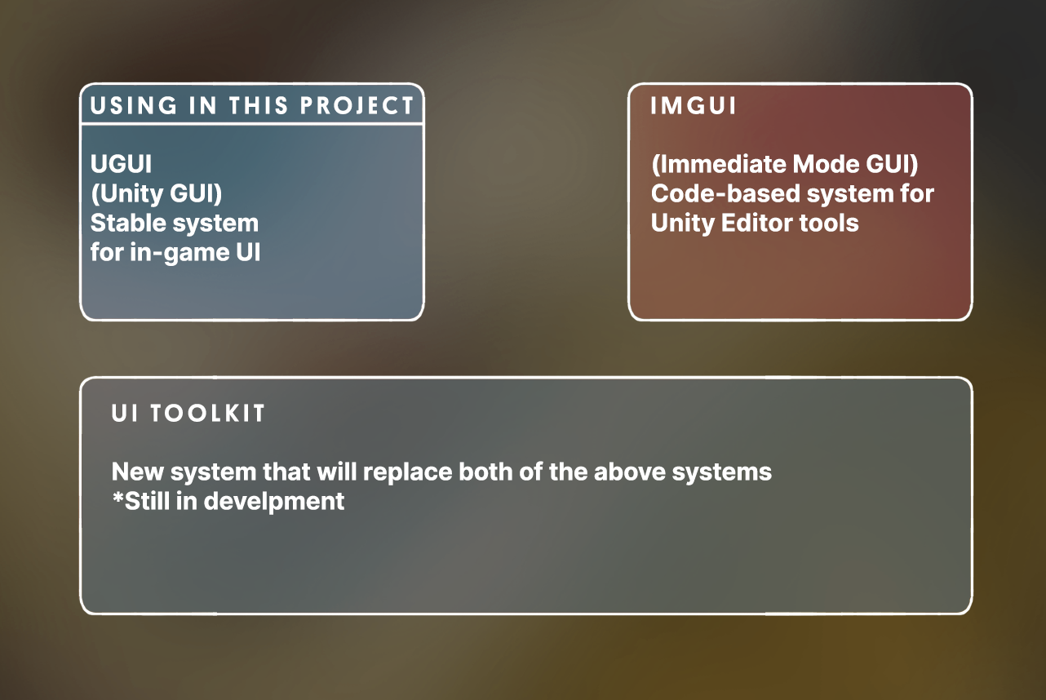
You can read more about the pros and cons of each system in the Unity User Manual.
Since the UI Toolkit is still in development, we will use the uGUI system in these tutorials. uGUI is the best option for applications in production today.
As you use the uGUI system, you will learn UI design skills that will be valuable regardless of the system you are working with.

Next steps
In this lab, you learned what a UI is and how it fits in with other related disciplines. Then you opened your project and customized your scene to get it ready for UI editing. In the next lab, you will add your first UI element: a title.

Text is at the core of UI design. It is a primary way to communicate information to users. If designed well, text is incredibly helpful and clear.
For an example of clean, consistent UI, check out Airbnb.com.
If designed badly, text can be ugly or overwhelming.
For an example of cluttered, confusing UI, check out Craigslist.com.
In this lab, you will add a title to your scene and make sure that it looks great.
2. Add and center your title text
Let’s add your project’s first UI element: the title.
1. In the Hierarchy, right-click > UI > Text - TextMeshPro. If a TextMeshPro Importer window pops up, select Import TMP Essentials. TextMeshPro (TMP) is a robust, easy-to-use text editing tool that is also optimized to display clearly on different screens.
The words New Text should now appear in the Game View screen in a pretty small font. If your text does not appear in exactly the same location or is a different size, that’s OK.
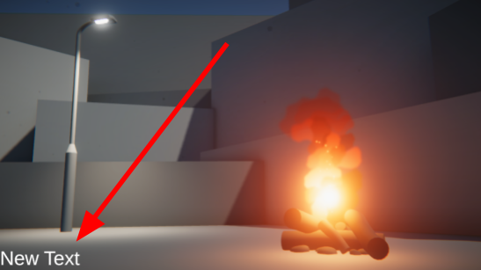
2. With the Text object selected in the Hierarchy, Locate the Pos X and Pos Y properties in the Rect Transform component. The Rect Transform component controls the position and scale of 2D rectangles.
3. Set Pos X to 0 and Pos Y to 0 to center the text on the screen.
If your text is right on top of another object, making it difficult to see, adjust the Pos X and Pos Y to fix that.
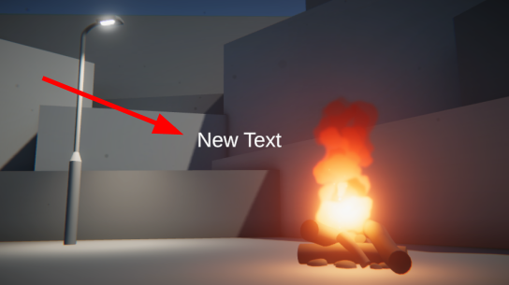
4. In the Hierarchy, rename the Text (TMP) GameObject to “Title text”.
You will also notice that a couple of new GameObjects were also automatically added to the Hierarchy the moment you created that text object.
There’s a Canvas object, which is a required parent object for any UI elements, and an EventSystem object, which manages UI interactions like button or toggle selections.
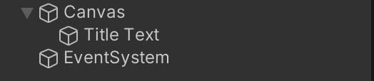
We’ll learn more about the Canvas and EventSystem in upcoming labs. For now, let’s make that title look a little better!
3. Customize your title text
1. With the Text object still selected, locate the TextMeshPro - Text (UI) component. You’ll use this component to customize the appearance of your text.
2. In the Text Input field, enter a new title for your project. It can be whatever you want. If it’s much longer than New Text, it will probably wrap onto multiple lines – we’ll fix that next.
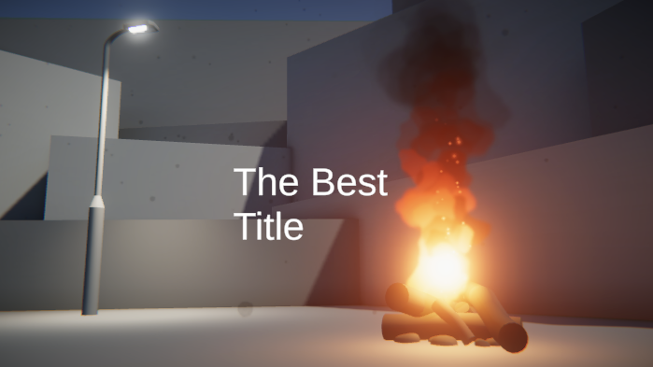
3. Change the Wrapping property to Disabled to allow your title to stay on one line.
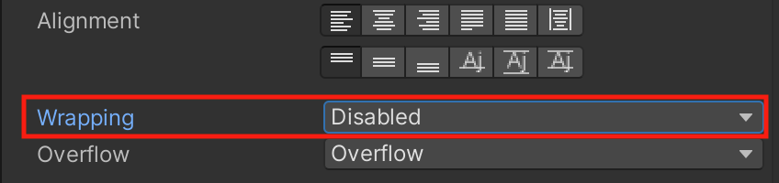
4. Customize the appearance and position of the text.
- In the TextMeshPro component, use the Font Asset, Font Style, Font Size, Vertex Color, Spacing, and other properties to customize your title’s appearance.
- Use the Pos X and Pos Y properties in the Rect Transform component to move the title around on the screen, but try to keep it pretty close to the center.
- If you want a line break at a particular point in your title, you can manually add it in the Text Input field.
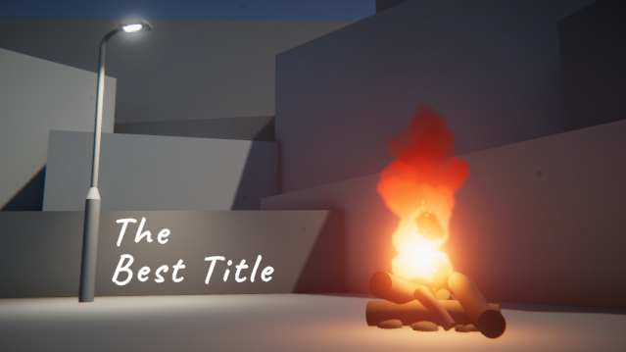
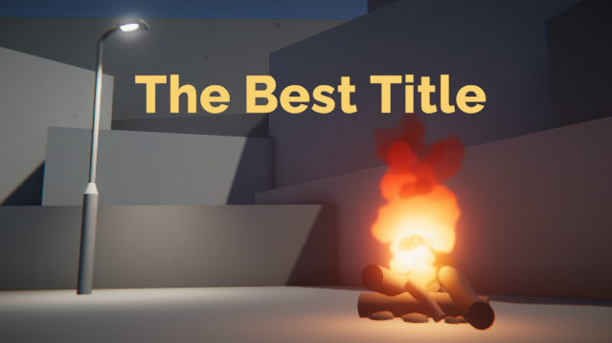
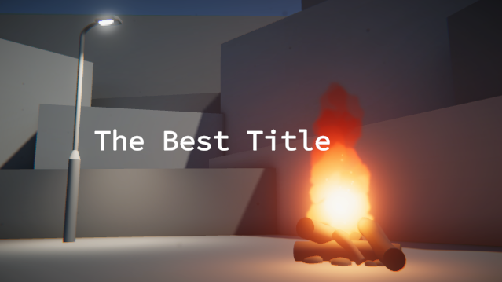
Your title should now look beautiful.
4. Make sure your text is accessible
What is text accessibility?
Before you become too attached to your title, let’s make sure it meets some basic accessibility requirements.
Accessibility refers to how well people with different physical abilities can successfully interact with your application. In the case of text, that mostly relates to visual accessibility.
Here are are a few specific things to consider:
- Text size: text should be large enough to read comfortably.
- Text contrast: text should stand out sufficiently from the background.
- Text font / typeface: text font should be easily legible.
- Text content: text should use familiar words written in a way that can be read by a screen reader.
Evaluate accessibility
Look at this example title below:
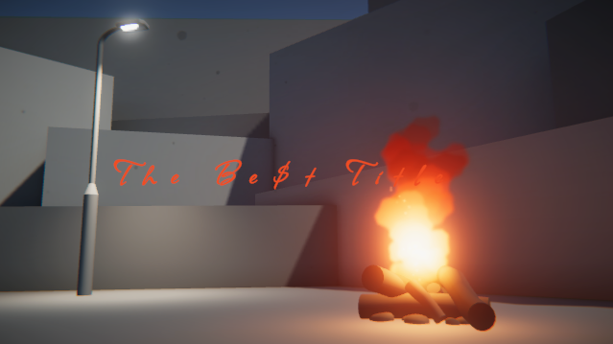
Try to identify what about this title would fail to meet accessibility requirements?
Check your work
In the example above, the title is too small, has insufficient contrast (especially around the fire), uses a hard-to-read font, and spells Best with dollar signs instead of an S.
This is obviously an extreme example, but even subtle alterations can mean the difference between whether or not someone can successfully navigate your application.
To learn more about the specifics of text accessibility, check out this additional information on text size, typefaces / fonts, contrast, and content.
Make edits to your title text
With an understanding of text accessibility, take a moment to make sure your title is accessible.
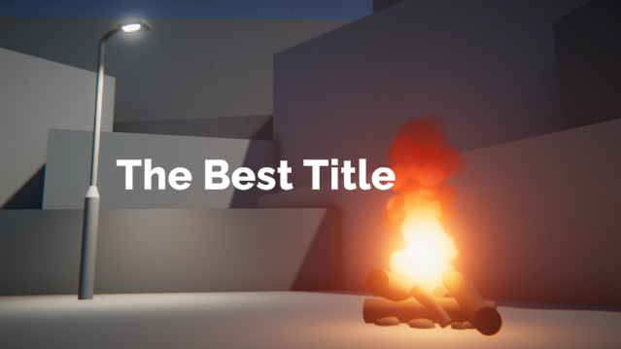
5. Explore: Download and import new fonts
In the TextMeshPro component, you will see there is a Font Asset property. Using the object picker, you can choose from a few fonts we’ve provided for you.
In order to use new fonts with TMP, you need to use TMP’s Font Asset Creator Tool. This will generate what is called a “font atlas”, which is used by TMP to display your text
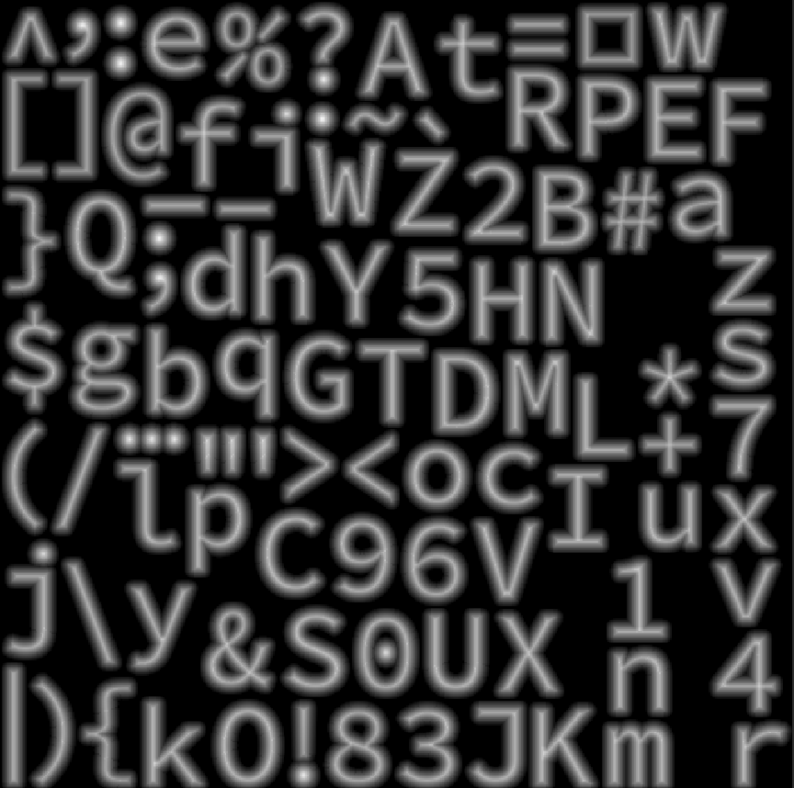
1. Browse online for open source fonts you like, which can legally be used in your project. Google fonts is a great resource for this.
2. Download any fonts you like as .otf or .ttf files, then import them into your project.
3. From Unity’s main menu, select Window > TextMeshPro > Font Asset Creator.
4. In the Font Asset Creator window, assign your font as the Source Font File, select Generate Font Atlas, and then select Save.
You should now be able to use your new font for your title!
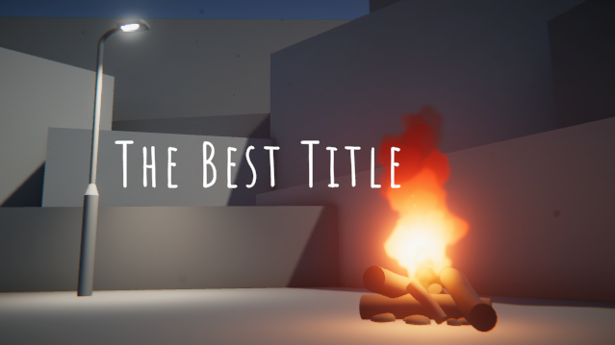
6. Next steps
In this lab, you added a title to the scene and made sure it was accessible.
In the next lab, we’ll dive deeper into positioning UI elements so that they look their best and respond appropriately on different screens.

